COURSE
Foundations of Supply Chain
About 94% of American homes have at least one jar of peanut butter in the pantry and chances are you have grown up eating the classic peanut butter and jelly sandwich. But have you thought about how that creamy goodness gets to the grocery store shelf? What about all of the people who are involved in creating such a nutritious product and how peanut butter impacts the world?
OBJECTIVE(S)
- Analyze the production of Skippy Peanut Butter from the peanut to the grocery shelf
- Map the supply chain of Skippy Peanut Butter
- Explain how the supply chain functions work together to support getting the final product to the consumer
TN STATE STANDARD(S)
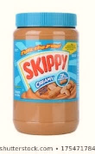
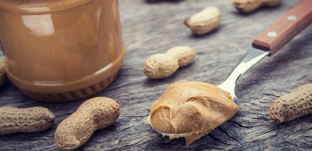
Supply Chain Functions #9: Gather and analyze information from multiple authoritative sources (i.e., industry magazines, academic journals) to explain how the following functions work together to support the final product/service being received by the customer at an optimal price-point: a. procurement of raw materials, b. selection of suppliers, c. transportation, d. warehousing/product storage,
PROJECT: JOURNEY OF PEANUT BUTTER
e. inventory control, f. material handling, g. information and communication systems, and h. employment/staffing processes
ESSENTIAL QUESTIONS

- What are the main ingredients of peanut butter?
- What are the steps involved in the production process of peanut butter—from the raw material to the consumer?
- How does each function of the supply chain impact the entire supply chain?

GRADING
Project is worth 100 points and will be graded based upon accuracy, completion, timeliness, and creativity.

INSTRUCTIONS

- As a class watch the video on “The Journey of Peanut Butter” at https://www.youtube.com/watch?time_continue=2&v=ypjIA4yaKf8

- Go to Hormel Foods (https://www.hormelfoods.com/inspired/story/behind-the-jar/) and read over the story “Behind the Jar”

- Map out the supply chain for Skippy Peanut Butter from the raw materials to the consumer – include which tier your suppliers are and your process flows

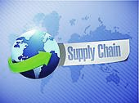
- Explain the role of each of the supply chain functions in getting the final product to the consumer at an optimal price-point. You can design a layout similar to the example below (or select a different SmartArt using MS Word). Make sure to write your explanation for each supply chain function in complete sentences and relate it back to the production of Skippy Peanut Butter.

