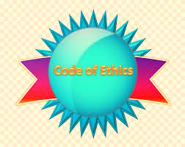
Project: Personal Code of Ethics

Course
Supply Chain Management II

Objectives
- Students will examine real examples of Codes of Ethics and analyze what these statements say about work culture and company values
- Students will write their personal Code of Ethics

TN State CTE Standards
Communications and Professionalism #4
Collect Codes of Ethics from various transportation, distribution, and logistics-related professional organizations and/or companies, identifying areas of commonality. Analyze what these statements say about the work culture at a particular organization and pinpoint company values that resonate with one’s own. Discuss how one would look for evidence of positive values when conducting a job search. Synthesize principles from the codes investigated to create a personal code of ethics to be included in a career portfolio compiled throughout the course.

Due Date - _______________________

Grading
Project will be graded using the Project rubric and will be worth 100 points.
_____________________________________________________________________

Pre-Project Activities
- Watch the video – BrainPOP Ethics - https://www.brainpop.com/health/personalhealth/ethics/
- Reading: How to Create a More Ethical and Sustainable Supply Chain
- Complete the activity Exploring Ethics

Project Activities
- Research Code of Ethics from various transportation, distribution, and logistics-related organizations and/or companies
- Analyze what these statements say about the work culture and values at a particular organization
- Using your research, create a personal code of ethics
- Document must be emailed to kavasschs@gmail.com no later than the assigned due date

