PROJECT: POPCORN BUSINESS DEVELOPMENT
Course: Intro to Business and Marketing
Objective(s):
- Develop a new and bold flavor of popcorn to sell in-person and online
- Develop a one-page business plan outlining your business—include your management, marketing, and financial plan
WHAT FLAVOR ARE
YOU
GOING TO CREATE?

- Develop all components of the marketing mix for your new business
- Create a presentation highlighting challenges, solutions, and results of your business development
TN CTE Standard(s):
14) Explain the purpose of a business plan and list the four major parts typically included (business description, management plan, marketing plan, and financial plan). Describe the importance of developing a business plan when seeking out potential investors or lenders. In preparation for a future career as an owner or entrepreneur, develop an original business philosophy detailing one’s beliefs for how a business should be run.
20) Describe the components of the marketing mix (i.e., price, product, promotion, and place). Investigate the launch of a new product or service; research how the company employed the marketing mix to aid in the launch; then create a presentation highlighting successes, challenges, and lessons learned. Additionally, critique the company’s strategies and suggest alternative ideas for future campaigns, following the principles of the marketing mix.
Grading: Project grade – 100 points (Project with Presentation Rubric)

PROJECT CHECKLIST
Pre-Project
- Video: Take This Job: Making Gourmet Popcorn - https://www.youtube.com/watch?v=aeOtlscFg6o
- Are you a sole proprietorship or a partnership?
- Determine Name of Business – Create a Logo
- Reading: Plan Now, Succeed Later

Part I – Product Development and Market Research
- Where Do You Find Popcorn? Summary
- Develop 2 flavors of popcorn
- Develop a score sheet for a tasting panel – conduct a tasting panel
- Develop an online survey (using SurveyMonkey) to test product

Part II – Budget and Pricing
- Start-Up Budget
- Determine product pricing

Part III – Package Design
- Construct the package
- Test prototype packaging
- Develop outside packaging graphics

Part IV – Advertising and Promotion
- Develop advertising for your product
- Develop promotions for your product
- Present ideas to class

Part V – Distribution
- Determine your channels of distribution

Part VI – Business Plan
- Create a one-page business plan using the Product One Page Business Plan Template
- Review sample business plans

PART I – PRODUCT DEVELOPMENT
Opportunities must be identified within the market for the development of new products or extensions of established product lines. Manufacturers often produce new lines to imitate competitors’ successful products, to capitalize on new consumer markets (known as “me too” lines in marketing). Opportunities for new products are isolated after extensive consumer research. Market researchers study buying habits, changing eating patterns, new and existing shopping methods and other trends that might influence the acceptance of new products. Research can also involve structured interviews with consumers, to gain more detailed insight into changing consumption patterns.
- Find out where popcorn is sold, both ready-to-eat and as kernels. Grocery stores, movie theaters, video stores, convenience stores, ball parks, fairgrounds, mall food courts and other fast-food outlets for ready-to-eat popcorn; grocery stores for kernels. Write a summary on the information found on the sale of popcorn.
- Develop ideas for flavoring 2 different types of popcorn. Investigate the suitability of different salts and seasonings, herbs and spices, flavored butters to drizzle onto hot popcorn, sweet flavorings such as caramel or brown sugar, or “trail mixes” with dried fruit and nuts.
- Devise a method of testing your finished popcorn flavors by means of a taste panel. Develop a “score sheet” which will evaluate qualities of flavor, texture, color, crunchiness, etc. Conduct your market research by surveying at least 20 individuals on both flavors of popcorn. Complete your Market Research worksheet.

PART II – BUDGET AND PRICING
An initial financial plan used by a business to commence operations under and obtain their initial funding objectives. A typical start-up budget will include essential purchases of machines, products, labor, and services, and it should help the new business by providing an action plan for allocating resources and meeting its goals. (http://www.businessdictionary.com/definition/start-up-budget.html)

Pricing your product – compute your markup based on retail price – markup must be at least 20%. Consider what promotional pricing you might offer to get your business started.
PART III – PACKAGE DESIGN
Design and construct a package for your new popcorn product. The following information summarizes the functions of packaging: It must contain, carry, protect, preserve, identify, display, and sell all aspects of the product. It should do so in a way that links the creativity of design with the functions of modern technology to fit the practical requirements of the goods to be packed. For food packaging must: Protect the food, act as a container to transport the food, provide vital information about the contents, and act as a means for display and storage in shops and supermarkets.
- Packaging protects food by preserving it and preventing it from spoilage. It forms a barrier against the atmosphere, protecting the food from air, dust, heat, light, moisture and bacteria. It must also transport the product to multiple destinations and thereby be capable of protecting the contents from damage. This is true for many food items, but especially for delicate foods such as eggs, delicate soft fruits and luxury items.
- Packaging has the fundamental role of conveying information about the product. The packaging must communicate facts about the name of the food, its weight, ingredients, nutritional information, where and how long to store the food and in what conditions, how the food must be prepared or cooked, the name and address of the company responsible and the country of origin, if applicable.
- Many food packages include bar coding which is a vital tool for food retailers, as electronic scanners “read” bar codes at checkout, providing information to improve inventory control and assist with market research. It also helps the customer by reducing time spent at the checkout.
- And finally, packaging helps sell the product. New products are constantly introduced into the market. This increases the selling functions of packaging design, which becomes a vital aspect of marketing the product. The packaging is often referred to as “the silent salesman.” At this stage, the packaging design often determines whether the product is purchased.
Design the labeling and graphics for the outside of your package that is suitable for the image and proposed “target market” for the product, taking the food labeling laws into account.
- Food labeling laws exist to protect the consumer and have been amended over the years as our understanding of food and nutrition grows. Increased consumer awareness and understanding of nutritional issues led to mandatory nutritional labeling on their products, thus helping consumers to achieve and maintain a healthy diet. Armed with this knowledge, consumers can avoid certain ingredients if they wish, which is especially important if they are following a specific diet.
- The following points summarize the functions of food labeling: It must convey information to the consumer, giving details of the product that will enable them to make informed choices, thereby helping consumers to decide between brands and package sizes, consider health consequences, value for money, etc.

Food labeling laws require the labeling on packaged food to fulfill several important functions. Where applicable, labeling should:
- Show the name of the food
- Show the amount of the food in the package
- List the ingredients used to make the food, in weight order
- State the name and address of the manufacturer, packer or distributor, and country of origin
- State how long the product can be stored and under what conditions
- Provide information on how to prepare and cook the food
- Provide a date mark to indicate when the product must be “used by” or is “best before” which is critical on items that are highly perishable and could easily cause a food safety risk
- Provide an accurate representation of the food contained in the package if photography is used

Design a logo or emblem for the label that will link the company with the product. The logo acts as an embodiment of the company’s style and can be a visual representation of the product or process but could be separate.
PART IV – ADVERTISING AND PROMOTION
Plan and develop your strategy for advertising and promotions campaigns for the new product. To be a success, the advertisement must communicate to the consumer, conveying the name of the product and its positive attributes. It must convince the consumer that the product is worth purchasing and entice them to try something new. Most importantly, the advertisement must be memorable so that at the time of purchase the consumer is able to recall the name of the product.
- A new popcorn product is about to be “launched.” Plan an advertising campaign for it, deciding which groups of people are most likely to eat it, and then develop ideas based on these groups – the “target market.” Write up your ideas and decide which media--magazines, newspapers, billboards, television, radio, the Web, or a combination--to use.
- Develop and plan the advertisement. Write the words and design the page for a newspaper advertisement, write the script or words for a jingle for radio, or produce a storyboard (small pictures with words that outline the sequence of shots) for television.
- Consider promotional ideas to help sell the popcorn product. Link the ideas to the advertising plans. You may want to design tee shirts, caps and stickers to tie in with your theme. Think about where you would sell or offer these items. Make plans and designs of your ideas.
- Present your advertisement and promotion ideas for the popcorn product to the class. Discuss and evaluate.

PART V – DISTRIBUTION
A distribution channel is a chain of businesses or intermediaries through which a good or service passes until it reaches the final buyer or the end consumer. Distribution channels can include wholesalers, retailers, distributors, and even the Internet (Source: Investopedia.com).
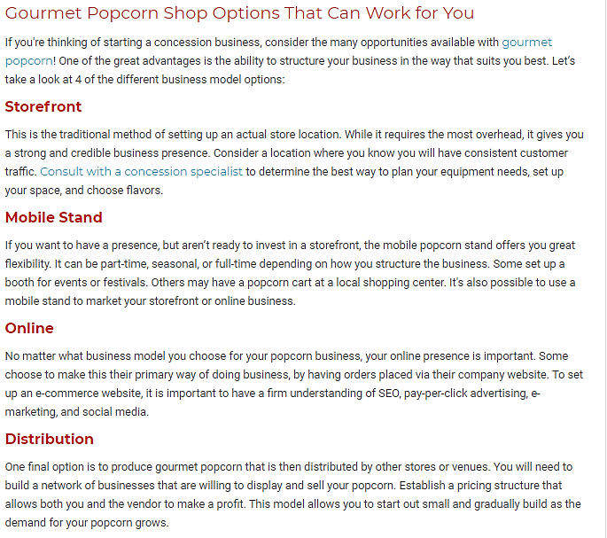
Source: https://www.gmpopcorn.com/concession-insights/build-your-concession-business/food-concepts/4-profitable-gourmet-popcorn-shop-business-models

