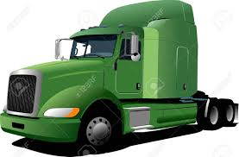
Course

Project: Transportation Scenarios
Foundations of Supply Chain Management

Objectives
- Students will problem solve to determine the most cost-effective and efficient mode of transportation for a particular product delivery

TN CTE State Standard(s)
Components of Supply Chain Management #13: Explore the five modes of transportation (truck, train, plane, ship, pipeline) used to move materials by land, air, or sea. Identify at least one carrier or service provider from each of the five modes of transportation. For each mode of transportation, analyze the costs, benefits, and problems associated with that mode of transportation, including environmental impact. List items that are most often transported by each type of transportation. Calculate the cost for various shipments using different shipment methods. Depict a comparison of the costs related to shipment methods using Microsoft Excel.

Due Date - _________________

Grading
Project will be graded using the Project Rubric and is worth 100 points.

Directions:
- Select a partner to work
- Read over your designated Transportation Scenario
- Research modes of transportation available to deliver your product – create a cost comparison sheet in MS Excel 2016
- Based on product, product organization, and dates, select your preferred mode of transportation for your scenario and explain why this one was chosen
- Email your project to kavasschs@gmail.com by the due date

