Project: Warehouse Process Flows

Course
Supply Chain I - Warehousing

Objectives
- Student will examine and compare the process flows in a distribution center such as Amazon and one such as Mahaffey USA in order to determine the desired layout of the warehouse/DC
- Student will create a floorplan for the warehouse/DC in MS Excel using a process flow that creates efficiency

TN CTE State Standards
Warehousing Management
15) Create a layout depiction for the work-based learning placement’s processing of incoming and outgoing, cross-docking, and storage of products. Provide a sketch of the shipping and receiving area and write out a standard operating procedure for each. 16) Create a flow chart for the processing of incoming goods and materials used at the work-based learning placement. Include processes for dealing with damaged, incorrect, and incomplete orders. 17) Job shadow or interview a warehouse manager or logistician and assess how they plan for the shipment of a product. Given a set of constraints, such as a specified timetable, destination, quantity, or other factors, determine how the number of pallets needed and assignment of dock doors to accommodate the appropriate number of loads is calculated.

Due Date _______________________________

Grading
Project will be graded using the “Project with Presentation Rubric” and is worth 100 points.

Resources
Warehouse Material Flows and Flow Charts, Interlake Mecalux, https://www.interlakemecalux.com/warehouse-manual/warehouse-design/warehouse-material-flowchart
Key Factors to Consider When Planning and Designing Warehouses, Logistics Bureau, https://www.logisticsbureau.com/warehouse-design-key-factors-to-consider/
Amazon Facility Tour - https://amazonfctours.com/navideotour
Mahaffey USA – www.mahaffeyusa.com

Background Information
Flows are the movements of the units as they enter the warehouse, move around it, and finally exit. There are three main types of flows: simple, medium, and complex.

Simple Flow

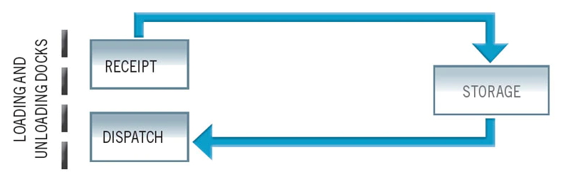

Medium Flow
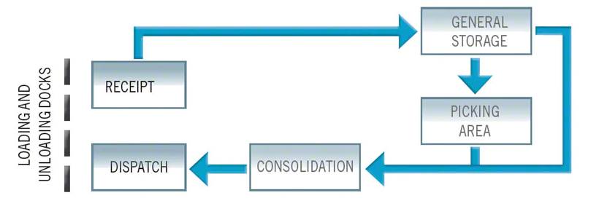

Complex Flow

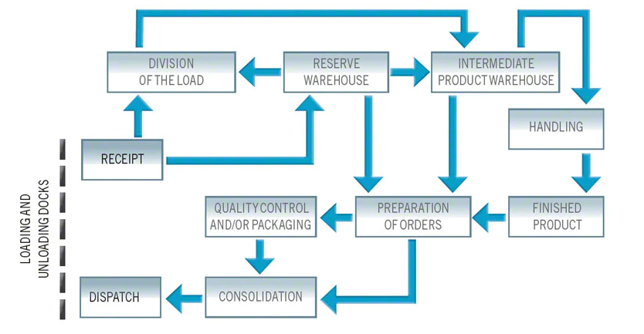

Field Trip
Mahaffey USA – Fall 2021

Pre-Project Activities
- Watch the video “Warehouse Layout & Product Flow Options” at https://www.youtube.com/watch?v=0OeStxbzKsM&t=40s
- Review the article “Key Factors to Consider When Planning and Designing Warehouses”
- Watch the video tour of an Amazon Facility - https://amazonfctours.com/navideotour
- What might be differences in the warehouse layout for Amazon and Mahaffey USA?

Project

Essential Question: How can a company structure its process flow in order to maximize space and movement in the warehouse/distribution center?

- Sketch the existing warehouse layout for Mahaffey USA
- Define the inputs and outputs
- Determine any special needs (or areas) the company will require
- Re-design the warehouse layout for Mahaffey USA – write a descriptive summary of why you choose this particular layout and how it can aid in efficient production (must use MS Excel for warehouse design)

