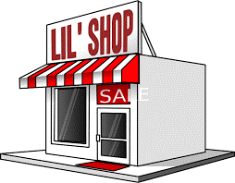
PROJECT: What Makes a Successful Entrepreneur
in the US

FOOD TRUCK PROJECT

Do you often wonder what it takes to be a successful entrepreneur? Let’s take a look at some published biographies of people who are worth millions because they put their ideas to work!

Directions: Choose a name from the following list or search for someone in the business world you are interested in. Then, research and answer the following questions in complete sentences. YOU ARE NOT ALLOWED TO USE WIKIPEDIA.

Create an infographic with the information you found. Make sure to cite your sources. Email assignment to kavasschs@gmail.com Name your assignment: lastname_activity_entrepreneur

To create your infographic, you may use any of the following software: canva.com, Venngage.com, or Picktochart.com

Assignment is worth 100 points.

___________________________________________

Sam Walton, Wal-Mart
Milton Hershey, Hershey Chocolate
Bill Gates, Microsoft
Mark Zuckerberg, Facebook
Elon Musk, Tesla
Jay-Z, Roc Nation and Roca Wear
Michael Jordan, Air Jordans
Jeff Bezos, Amazon

Questions:

- What is the name of the entrepreneur you read about? What website did you access?
- What is the name of the company he/she owns?
- What product(s)/service(s) does the business sell/produce?
- How did the business start? Year?
- At what age did he/she realize that they wanted to start a business or sell a product?
- Where did the idea come from?
- How/where did he/she receive funding to get started?
- What aspects of this business make it so successful?
- What risks do you suppose were involved with the start-up of this business (remember to think about competition, location, product need/demand, initial costs, etc.)?
10. What is the future outlook for this business?

