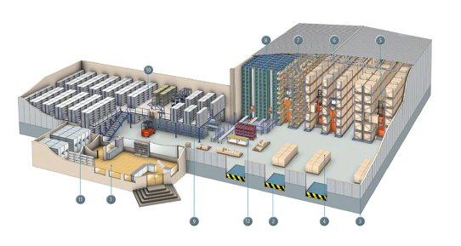
QUIZ: Warehouse Receiving Calculations

Name________________ Class ___

Directions: Complete the following Quiz on Warehouse Receiving calculations. Quiz is worth 40 points.

Warehouse receiving: Use the tihi formula to calculate the number of cases contained on each pallet.
1. Item #301 Sensors tihi 12:7
2. Item #402 Gauges tihi 8:5
3. Item #503 12” hoses tihi 4:6
4. Item #604 Switches tihi 8:6
5. Item #705 Valves tihi 10:5

Warehouse storage: Complete the following storage calculations.
6a. You will be receiving a shipment of 280 cases of item #306; there are 56 cases on each pallet. The pallets are to be stored in section F5 of the warehouse. If 2 pallets fit on a storage rack, how many racks will you need for the cases?
6b. If there are 6 racks available in section F5, how many open racks will remain after storing the cases?
7a. You will be receiving a shipment of 576 cases of item #307; there are 48 cases on each pallet. The pallets are to be stored in section F6 of the warehouse. If 4 pallets fit on a storage rack, how many racks will you need for the cases?
7b. If there are 4.75 racks available in section F6, how many open racks will remain after storing the cases?

Warehouse Inventory: Calculate the inventory for the following products and complete the inventory log.
8. Item #203 8 full pallets and 23 cases; pallet tihi 4:7; 12 units per case
9. Item #204 5 full pallets and 31 cases; pallet tihi 6:8; 6 units per case
10. Item #205 3 full pallets and 14 cases; pallet tihi 8:12; 4 units per case

