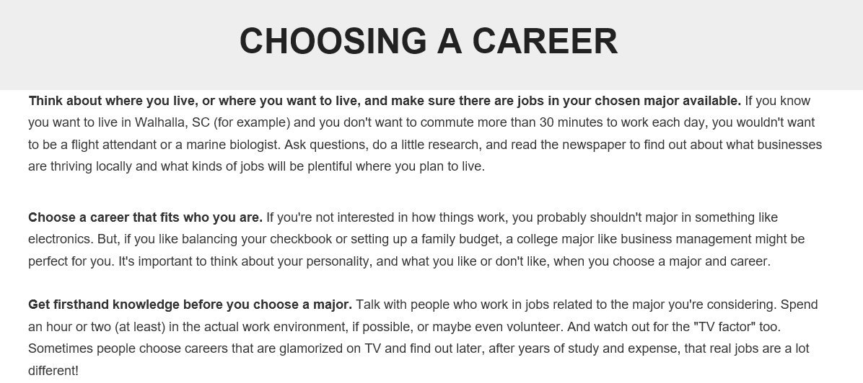
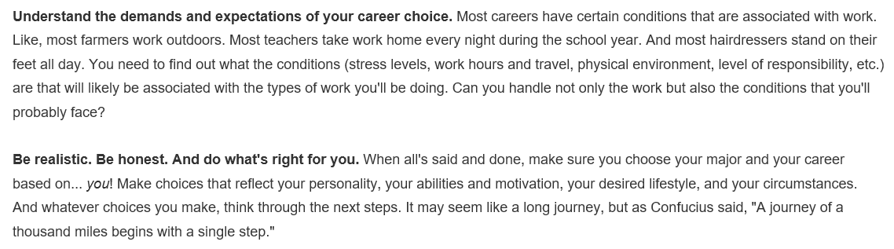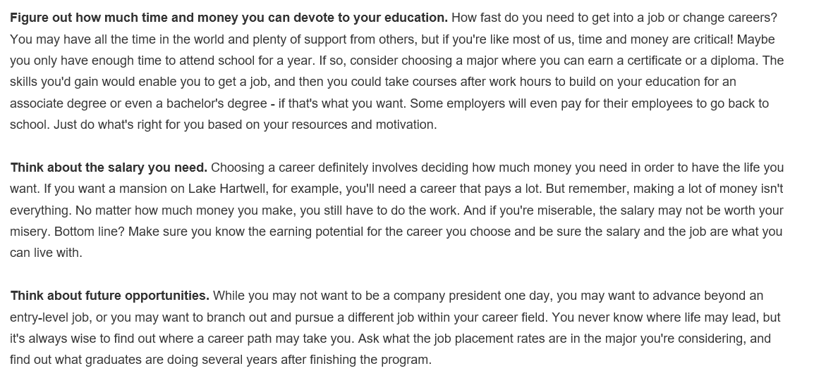
Source: https://www.tctc.edu/life-at-tctc/student-services-and-support/career-services/choosing-a-career/
________________________________________________________________________________________________________
DIRECTIONS: Read this article about different things to consider when choosing a career. When you finish, list the THREE things from this article that you feel are most important to keep in mind as you consider possible careers.

