Name(s): Period: Date:

Reading: Import Tariffs and your Bottom Line

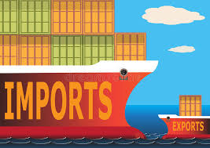
Background – Import Tariffs Impact the Bottom Line
Ella has been very successful in selling her card game 35 to Win in a small Etsy store online. While she was selling to various game stores she found that her local area did not even have a place to buy games like her card game. Ella partnered up with a friend to start their own game store they are calling Ella’s Game Emporium. Most of their business is online, but they found a store location where they can keep a large storage and shipping and handling office but still have a small storefront where people can stop by to buy a game.

Many of the most interesting new games are actually developed outside of the US, so Ella needed to figure out more about importing goods so that she can sell them here in the US. When goods are imported from another country it is important to calculate the duty that will be charged and include that when calculating the sales price of the item.

A duty is an import tax. When goods are imported from other countries a tax is charged. Import taxes are a way to help keep the local goods competitive with the goods that come from another country. In the United States it costs a lot more to make a product because we have laws that protect our workers. We have a minimum wage, our workers have a right to healthcare, we have to pay overtime when workers are stuck at work for more than 8 hours and labor unions ensure that trained workers have a living wage. We also have a much higher cost of living than most other countries and have high safety standards. While US manufacturing workers earn compensation of around $35 per hour, in China and India they earn less than $2 per hour in compensation.

The low compensation for overseas manufacturing labor is the primary reason that so many manufacturing companies have moved overseas. The cost difference of transporting the goods all the way across the ocean is minimal compared to the difference in manufacturing costs due to labor prices.

In order to protect companies who have stayed in the US, the government charges duties, also known as tariffs, to even out the price when you get to the store. Even with these taxes, the goods from international markets are still less expensive than many American made products, however these duties helps to keep the US prices somewhat competitive with international markets.

Although there is a specific duty on each type of good, with higher taxes on certain luxury items and other items being exempt of taxes besides port processing fees. Overall, the average duty levied on goods entering the USA is around 3%, but can vary from 0 to 20% so we will apply percentages in that range to Ella’s imports.
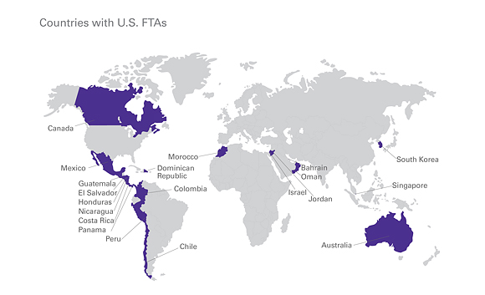
https://smallbusiness.fedex.com/international/free-trade-agreement.html
There are also countries we trade with freely because we have made Free Trade Agreements (FTA’s) with those countries.

The North America Free Trade Agreement (NAFTA) allows for free trade for most goods between Mexico, Canada and the United States. There are many benefits of this free trade agreement. Many of the raw materials that the US uses in their American Made products come from Canada or Mexico, reducing the cost of these products overall. This agreement also benefits consumers, allowing for lower prices at the stores in the United States. NAFTA is also controversial because jobs moved to Mexico where labor costs less but the company can import to the USA without taxes. In any free trade agreement, the taxes on goods that are imported are based on the origin of the goods, so another company cannot bring goods to Mexico with a low import rate then bring them to the US for free. This is the reason that many times raw materials are shipped from another country, the product is created in Mexico and then can be imported tax free to the US as it is considered to be Made in Mexico.
https://ustr.gov/trade-agreements/free-trade-agreements/north-american-free-trade-agreement-nafta

The intricacies of trade taxes are much more complicated than this activity, but it gives you an idea of how globalization has changed the world of business. In order to help companies get their goods through customs, they often hire a customs broker who will file the proper paperwork and ensure the goods make it through customs quickly.

Questions

- List three reasons that the US has a higher wage for manufacturing workers than other countries.

- What is the primary reason that companies move their manufacturing plants out of the US?

- What is the average duty percentage on goods imported into the USA without a Free Trade Agreement?

- Write an expression to represent the total cost of a good if this percentage is added to the purchase price of that good (p)?

- What is NAFTA and which countries are part of NAFTA?

