READING: It’s All Our Business
Directions: Read the article and answer the questions under Total Recall at the end of the article. Assignment is worth 100 points.
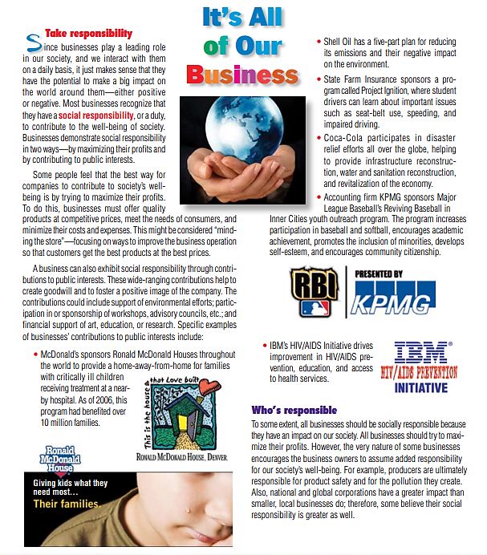
e $41 billion dollar firm Uber Technology, Inc., is unsettling
the traditional taxi business. In over 40 countries and 240 mar-
kets around the world, Uber and similar companies are chal-
lenging the existing taxi business model. Uber and its growing
list of competitors, Lyft, Sidecar, and Flywheel in America, and
fledging rivals in Europe, Asia, and India, think their smart
phone apps can provide a new and improved way to call a taxi.
This disruptive business model uses an app to arrange rides
between riders and cars, theoretically a nearby car, which is
tracked by the app. The Uber system also provides a history of
rides, routes, and fees as well as automatic billing. In addition,
driver and rider are also allowed to evaluate each other. The
services are increasingly popular, worrying established taxi ser-
vices in cities from New York to Berlin, and from Rio de Janeiro
to Bangkok. In many markets, Uber has proven to be the best,
fastest, and most reliable way to find a ride. Consumers world-
wide are endorsing the system as a replacement for the usual
taxi ride. As the most established competitor in the field, Uber
is putting more cars on the road, meaning faster pickup times,
which should attract even more riders, which in turn attracts
even more drivers, and so on. This growth cycle may speed the
demise of the existing taxi businesses as well as provide sub-
stantial competition for firms with a technology-oriented model
similar to Uber’s.
The Uber business model initially attempts to bypass a
number of regulations and at the same time offer better service
and lower fees than traditional taxis. However, the traditional
taxi industry is fighting back, and regulations are mounting.
The regulations vary by country and city, but increasingly spe-
cial licensing, testing, and inspections are being imposed. Part
of the fee charged to riders does not go to the driver, but to
Uber, as there are real overhead costs. Uber’s costs, depending
on the locale, may include insurance, background checks for
drivers, vetting of vehicles, software development and mainte-
nance, and centralized billing. How these overhead costs com-
pare to traditional taxi costs is yet to be determined. Therefore,
improved efficiency may not be immediately obvious, and
contract provisions are significant (see
www.uber.com/legal/
usa/terms
).
In addition to growing regulations, a complicating factor in
the model is finding volunteer drivers at inopportune times. A
sober driver and a clean car at 1:00 a.m. New Year’s Eve does
cost more. Consequently, Uber has introduced “surge” pricing.
Surge pricing means a higher price, sometimes much higher, than
normal. Surge pricing has proven necessary to ensure that cars
and drivers are available at unusual times. These higher surge
prices can be a shock to riders, making the “surge price” a conten-
tious issue.
Discussion Questions
1. The market has decided that Uber and its immediate competi-
tors are adding efficiency to our society. How is Uber providing
that added efficiency?
2. Do you think the Uber model will work in the trucking
industry?
3. In what other areas/industries might the Uber model be used?
Sources: Wall Street Journal (January 2, 2015), B3, and (Dec. 18, 2014), D1;
and www.bloombergview.com/articles/2014-12-11/can-uber-rule-the-world .

