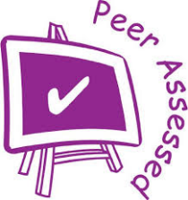
RUBRIC – PEER ASSESSMENT

List your team members, including yourself, in the space provided below. Then, rate every person on each behavior listed. Use the following rating scale:

4 = Always 3 = Usually 2 = Sometimes 1 = Never

