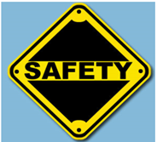
SAFETY UNIT – TN Teen Work Hours Activity

Name ___________________________ Class ____

Directions: Review the chart on Work Hours for TN Teens and then address the scenarios provided. Assignment is worth 30 points.
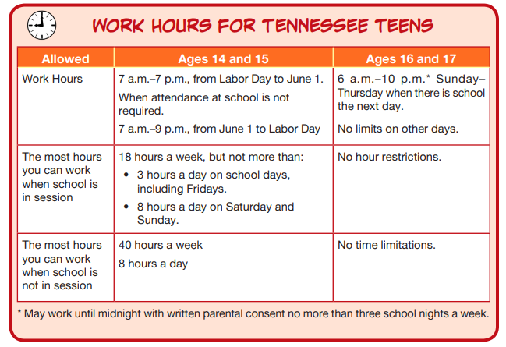

Source: https://www.cdc.gov/niosh/talkingsafety/states/tn/2015-157/pdfs/Talking_Safety_TN.pdf

- Daniel (aged 17) works at a fast food restaurant with scheduled hours from 5 – 10 pm, but his boss usually makes him stay until 10:30 to help close. Is this allowed? Why or why not?

- Sandra is age 15 and interviewing for a position as a lifeguard during the school year. How many hours can she work a week?

- Ryan works at Lowe’s as a part-time worker. He ends classes at 12:30 and has just a study hall after that. His boss asked him if he wanted extra hours and he said yes. So, he leaves school at 12:30 pm to go to work. Is this allowed?

