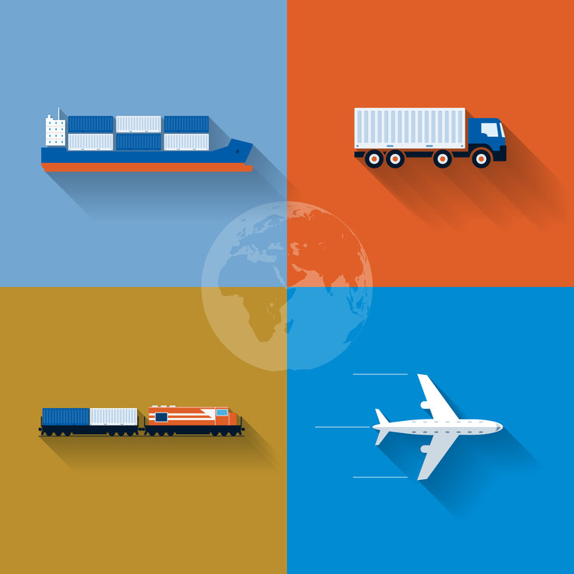

TRANSPORTATION UNIT INSTRUCTIONS

Course
Foundations of Supply Chain Management

Objectives
- Students will examine the 5 modes of transportation
- Students will describe the advantages and disadvantages of each mode of transportation
- Students will analyze the decision factors involved in selecting transportation methods
- Students will describe the different types of freight handling
- Students will calculate various types of transportation problems relating to truck driving, delivery, and maintenance

TN State CTE Standards
Components of Supply Chain Management #13: Explore the five modes of transportation (truck, train, plane, ship, pipeline) used to move materials by land, air, or sea. Identify at least one carrier or service provider from each of the five modes of transportation. For each mode of transportation, analyze the costs, benefits, and problems associated with that mode of transportation, including environmental impact. List items that are most often transported by each type of transportation. Calculate the cost for various shipments using different shipment methods. Depict a comparison of the costs related to shipment methods using Microsoft Excel.

Essential Questions
- Describe the 5 modes of transportation
- What are the advantages and disadvantages for each mode of transportation?
- What factors must companies considering when transporting their goods?
- What are the costs associated with each mode of transportation?
- What is the environmental impact for each mode of transportation?

Duration
3 weeks

ACTIVITIES
Assignment | Due  Date | Date Completed | Grade
Transportation PPT
Glossary: Transportation Unit
Activity: Name That State
Reading: Trucking Rises to Meet Unprecedented Challenges During COVID-19 Pandemic
Activity: Advantages and Disadvantages of the 5 Modes of Transportation
Activity: Track the Independence
Activity: Which Mode of Transportation?
Activity: Modes of Transportation Crossword Puzzle
Quiz: Modes of Transportation (Quizziz)
Project: American Truck Simulator
Activity: Test Your Knowledge of Truckload
Activity: Transportation Math Worksheet
Case Study: Last-Mile Delivery
Project: Transportation Scenarios
Unit Exam: Transportation

