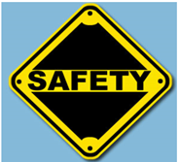
SAFETY UNIT – What Should You Do Activity

Name ___________________________ Class ____

Directions: Answer “What Should You Do?” for each of the scenarios listed below. Assignment is worth 30 points.

 | QUESTION | 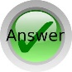  ANSWER
 | If you smell smoke and suspect there is a fire somewhere in the building, what should you do?
 | If an unknown chemical spills in your workplace, what should you do?
 | If you are in a building and hear a tornado warning siren, what should you do?
 | If someone tries to rob your workplace with a gun, what should you do?
 | How many exit routes must a workplace have?
 | What are the steps for using a fire extinguisher?
 | You are working on a construction site and a co-worker enters a trench and passes out. What should you do?
 | What should you use to put out a grease fire on a stove?
 | If a co-worker falls off a ladder and injures her back, what should you do?
 | If your clothes catch on fire, what should you do?
 | What is at least one item that should be included in an emergency kit?
 | If a chemical gets into your eye, what should you do?
 | If you are working outside when a lightning storm starts and you can’t get to shelter, what should you do?
 | What should you do if you come in contact with a substance but don’t know whether it is toxic?
 | What two common cleaning products should you never mix, because they can make a gas that can kill you?

Source: https://www.cdc.gov/niosh/talkingsafety/states/tn/2015-157/pdfs/Talking_Safety_TN.pdf

